Luke Pepin

GEOG 1700 – Practice Assignment

1/19/2024

1) Identify a location in another region of the world that you think sounds interesting, have been to and appreciate, or have some other connections to.

A location in another region of the world that I find interesting is Australia. Particularly its diverse wildlife despite harsh conditions. Its wide range of temperatures such as the scorching heat of the Outback to milder climates along the coastline offering varied weather conditions is another reason, I find it interesting.

2) Use your favorite browser to find an image of this place. Select the image and then select copy

3) In a document (could be any type of document), paste the image and type the name of the location, as well as your name and the date.

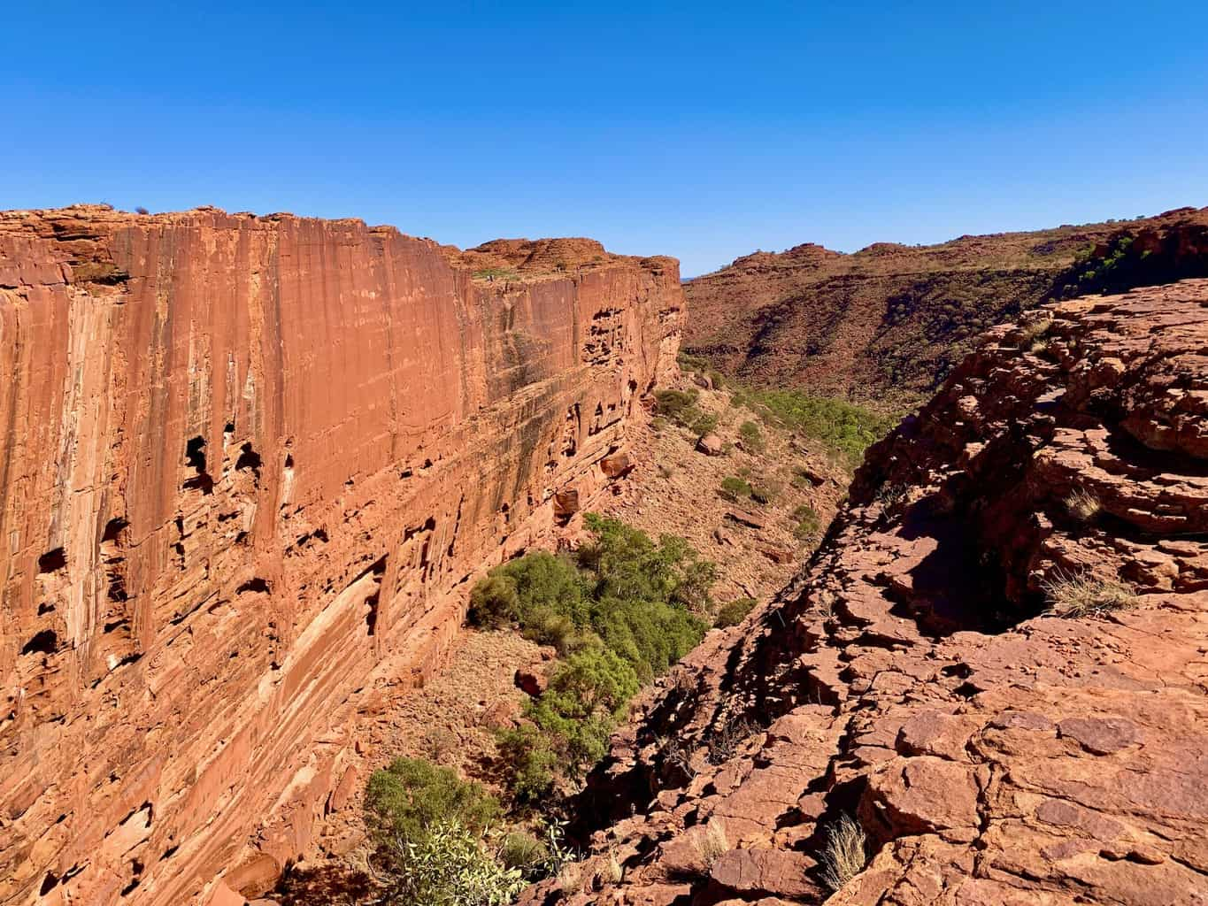

Kings Canyon Access, Petermann NT 0872, Australia

Luke Pepin

1/18/2024

4) Save the document as PDF format

5) Upload your PDF file with the image and your location name to this site.